**Desertification**

**--**

**Overall thoughts**

* Satellite temporal coverage should be long enough to see changes
* Methods commonly include change detection/classification of levels of desertification
* NDVI, TGSI, Albedo used
* Interesting thing to apply would be ML of sand dunes to analyse when immobile sand dunes become mobile sand dunes showing desertification

**--**

<https://www.youtube.com/watch?v=D6Kz_OcOgvE>

* This video has such earth explorer visualisation at 1 to 2 min mark. Some ideas include shrinking water body, treeline, urban development, etc.

**The use of remote sensing for desertification studies: A review (Marin et al., 2022) -** [**https://eprints.soton.ac.uk/469702/**](https://eprints.soton.ac.uk/469702/)

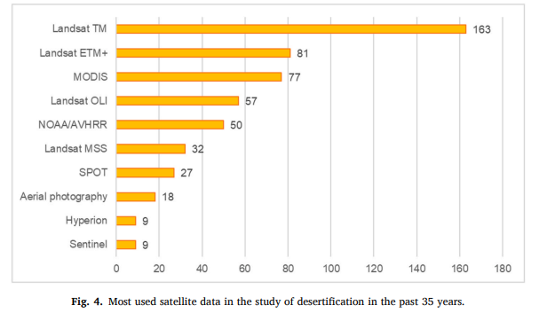

* Access to longer timeframe necessary for change detection

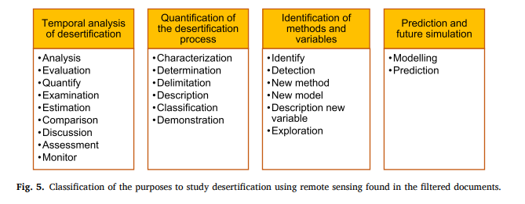

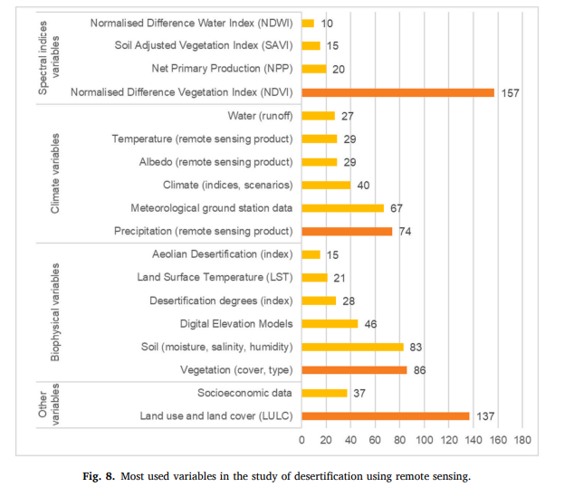

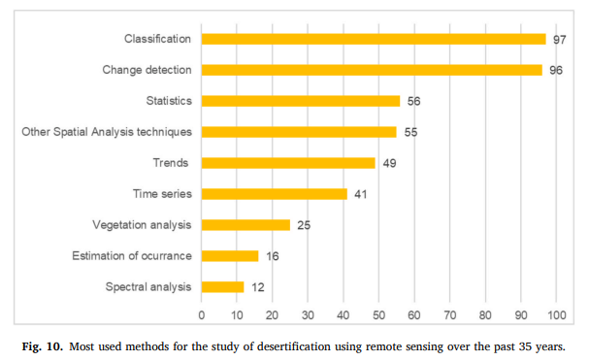

**Using remote sensing technology to detect, model and map desertification: A review (Albawi and Kumar, 2013)**

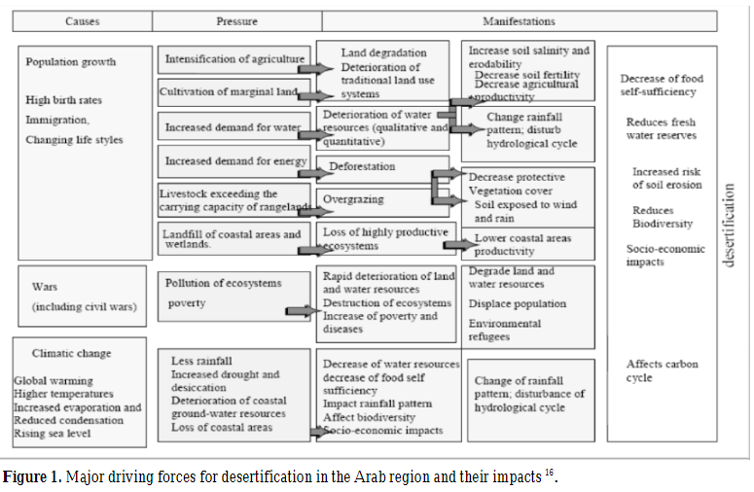

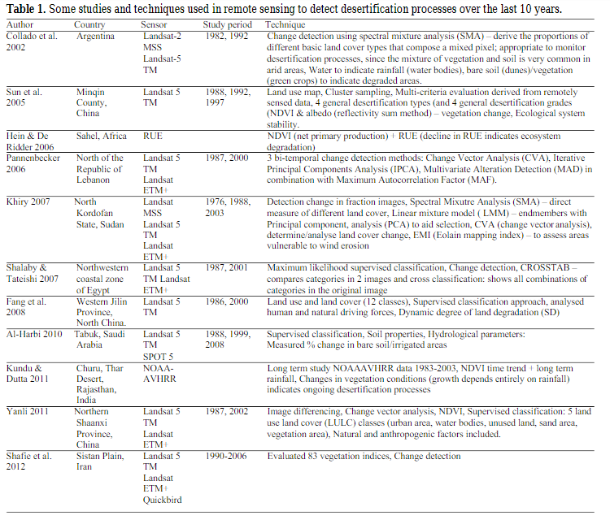

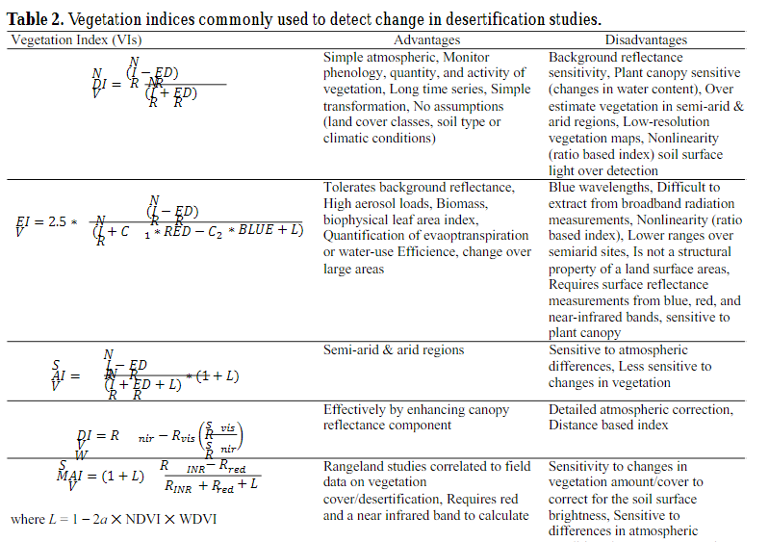

* Drought
  + Monitor plant available moisture and land cover type
  + Studied through NDVI (reflectance bands) and Land Surface Temperature (LST) (thermal bands)
* Soil
  + Grain Size Index of topsoil to assess land degradation
* Urbanisation
  + Classify land use and urban development to detect the impact of urban growth and desertification

**Integration of remote sensing techniques for monitoring desertification in Mexico (Becerril-Pina et al., 2016)** - <https://www-tandfonline-com.libproxy.ucl.ac.uk/doi/full/10.1080/10807039.2016.1169914>

* Methods for evaluating desertification by remote sensing include visual interpretation, classification algorithms and spectral mixture analysis
* Use of Landsat TM 5 for 1993 to 2011
* Categories of land cover: water body, urban zone, forest, rainfed agriculture, irrigation agriculture and grass-shrub cover
* Bare-Soil Index (BSI), NDVI, SAVI and albedo
* Change Vector Analysis to assess changes between references and target date
* Desertification degree index (DDI) to make map of areas showing low to extreme desertification

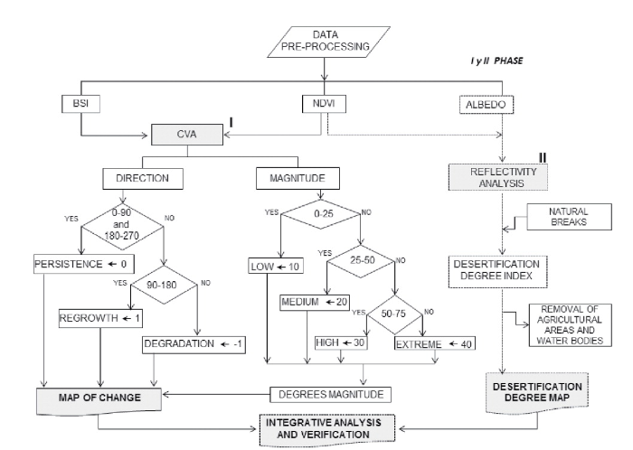

**Assessment of land cover change and desertification using remote sensing technology in a local region of Mongolia (Lamchin et al., 2016)**

* Landsat TM/ETM+ data
* NDVI, Topsoil Grain Size Index (TGSI) and land surface albedo were selected as indicators for representing land surface conditions from vegetation biomass, landscape pattern, and micrometeorology
* Desertification decision tree

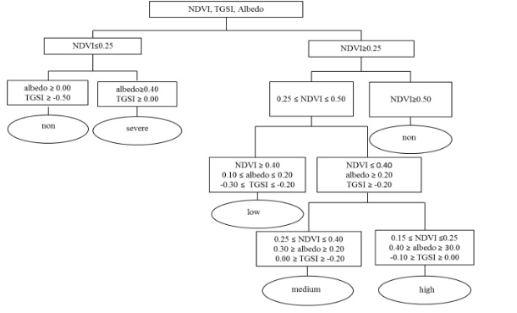

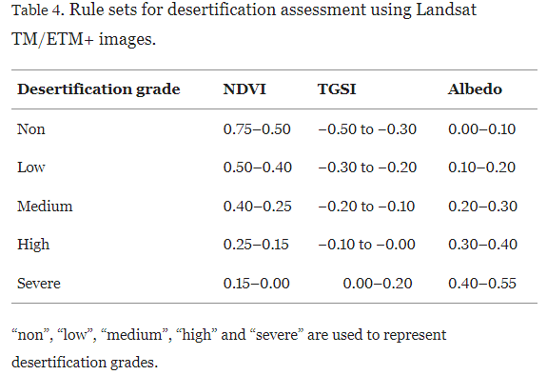

**Remote-sensing monitoring of desertification, phenology, and droughts (Karnieli and Dall’Olmp, 2003)** - <https://www-emerald-com.libproxy.ucl.ac.uk/insight/content/doi/10.1108/14777830310460360/full/html>

* NOAA-14 satellite used with coarse spatial resolution and high revisit time
* NDVI and land surface temperature (LST) used
* NDVI values correspond to the reaction of vegetation to rainfall
* LST reveals that the NDVI values correspond to the reaction of the vegetation to rainfall and that LST values represent seasonal climatic variation

**Review of Desert Mobility Assessment and Desertification Monitoring Based on Remote Sensing (Wang, Shi and Zhang, 2023)** - <https://www.mdpi.com/2072-4292/15/18/4412>

* Visual interpretation: susceptible to subjective interpretations when recognising desert features
* Non-linear spectral model: spectral mixture analysis (SMA) is used to retrieve vegetation coverage. Estimate photosynthetic vegetation and non-photosynthetic vegetation. Future research needed on accuracy especially given complex cases with multiple scattering
* NDVI: when ground is predominantly covered by vegetation, exceeding 30% of total coverage, sand movement nearly ceases. Regression models between vegetation coverage and NDVI. However, stability of NDVI data remains insufficient which may lead to lower accuracy in the model estimation
* Plant community classification: grouping of plant types that exhibit interconnected relationships between species and their environment. Combination of multiangle imaging spectroradiometer (MISR) multiangle data through multiangle reflectivity, surface anisotropy patterns and support vector machine algorithm. Focus of research is the detailed classification of sparse vegetation and bareland. Relying solely on vegetation coverage as a single index is insufficient
* Desertification involves gradual deterioration of soil organic matter content, progressive reduction in the vegetation and water coverage of the soil surface
* Alternative of classification methods of moving dunes based on deep learning
* Dine ridge line extraction results using different algorithms

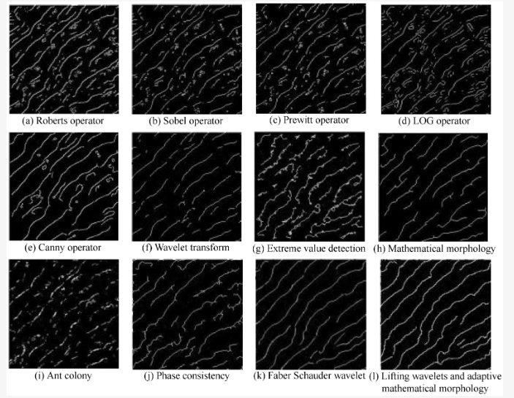

* Identify mobile desert region. Fixed deserts do not expand while mobile deserts migrate and expand, leading to desertification due to various factors

**Correlation between desertification and environmental variables using remote sensing techniques in Hogno Khaan, Mongolia (Lamchin et al., 2017) -** https://www.mdpi.com/2071-1050/9/4/581

* Factors: NDVI, TGSI, land surface albedo, topographic wetness index (TWI), land surface temperature (LST), perpendicular drought index (PDI) and elevation
* Normalised indicators, determine weights, determine five levels of desertification and test correlations between variables in comparison to different levels of desertification

**Monitoring desertification by remote sensing using the Tasselled Cap transform for long-term change detection (Zanchetta, Bitelli and Karnieli, 2016) -** https://link-springer-com.libproxy.ucl.ac.uk/article/10.1007/s11069-016-2342-9

* Landsat 8 OLI system
* Azraq has been subject to complete drying up of superficial springs due to overexploitation of groundwater basin
* Change Vector Analysis and Tasselled Cap transformation (designed to analyze and map vegetation phenomenology and urban development changes detected by various satellite sensor systems) as method
* In general (considering the two bands space) an indicator of the soil reflectance and an indicator of the vegetation vigor are used, like Albedo and NDVI (Normalized Difference Vegetation Index) (Karnieli et al. [2014](https://link-springer-com.libproxy.ucl.ac.uk/article/10.1007/s11069-016-2342-9#ref-CR27)) or the Tasselled Cap features Brightness and Greenness (Malila and Lafayette [1980](https://link-springer-com.libproxy.ucl.ac.uk/article/10.1007/s11069-016-2342-9#ref-CR33)).

